**Name:** Ahmed Mahmoud Amer Ouda **Topic**: Artificial Intelligence

**Code:** 137

|  |
| --- |
|  |

**Application Brief**

Artificial Intelligence and the technology are one side of the life that always interest and surprise us with the new ideas, topics, innovations, products …etc. AI is still not implemented as the films representing it (i.e. intelligent robots), however there are many important tries to reach the level and to compete in market, like sometimes the robots that they show in TV. Nevertheless, the hidden projects and the development in industrial companies.

At the end, we’ve been in this research through the AI definitions, brief history, application of AI in public, applications of AI in military, ethics of AI, and the three rules of robotics. This is not the end of AI, there is more to come from it, who knows what the AI can do for us in the future, maybe it will be a whole society of robots.

|  |
| --- |
| **Links**  Github link: <https://github.com/ahmed222002/html-project-repository> Github padges (puplished-website) : <https://ahmed222002.github.io/html-project-repository/>  **Source Code**  <html>     <body   style="background-image:url('cccc.jpg')">       <h1 style="font-size: xx-large;color:rgb(0, 217, 255);">Home</h1>    <ul>      <li><a href="What is AI.html"><h2 style="font-size: xx-large;font-family: Verdana;color:rgb(252, 252, 252);">What is AI</h2></a></li>      <li><a href="The Aim of AI.html"><h2 style="font-size: xx-large;font-family: Verdana;color:rgb(248, 245, 245);">The Aim of AI</H2></a></li>      <li><a href="Categorization.html"><h2 style="font-size: xx-large;font-family: Verdana;color:rgb(252, 250, 250);">Categorization of AI</H2></a></li>      <li><a href="Applications of AI.html"><h2 style="font-size: xx-large;font-family: Verdana;color:rgb(248, 247, 247);">Application of AI</H2></a></li>    </ul>    </body>  </html> |

**Screen Shots of WEB site**

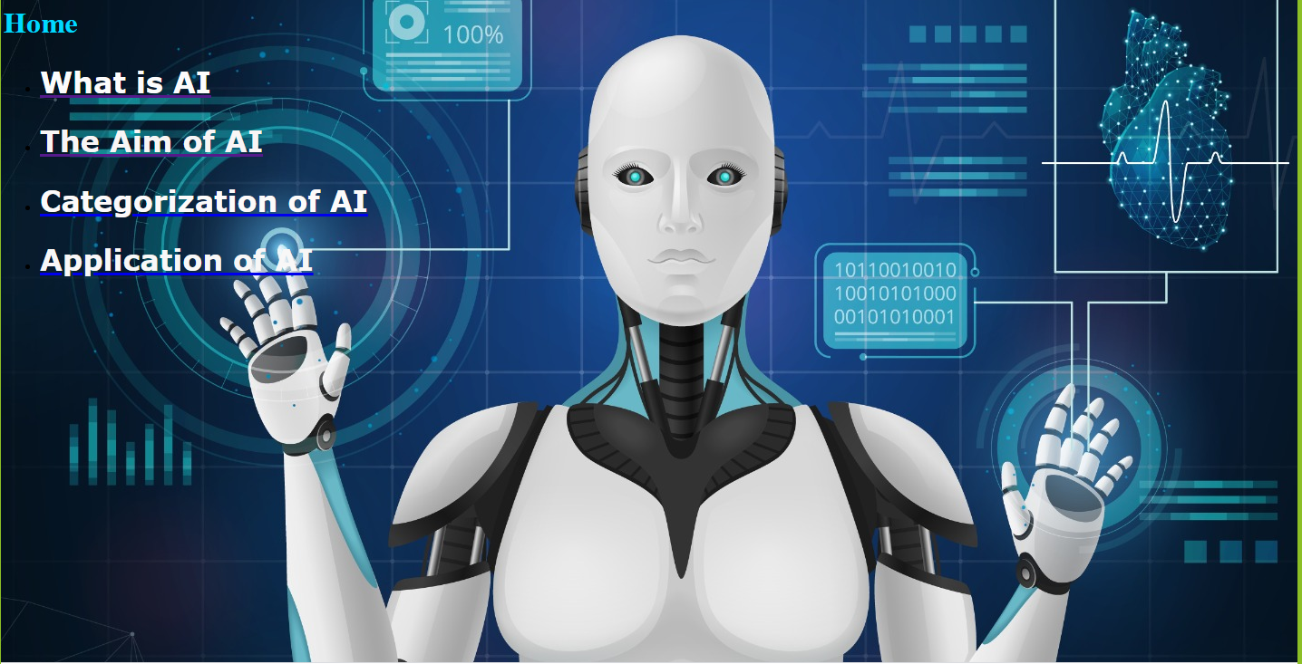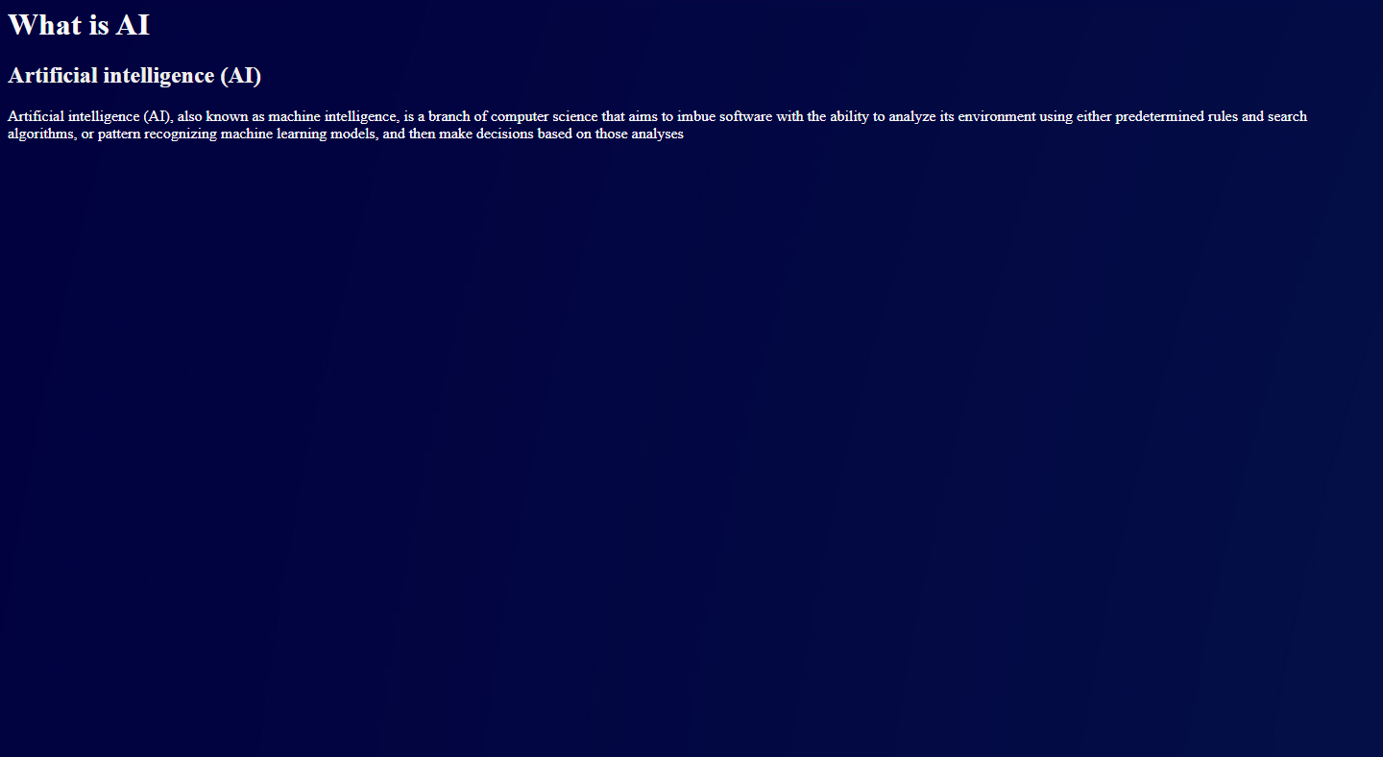

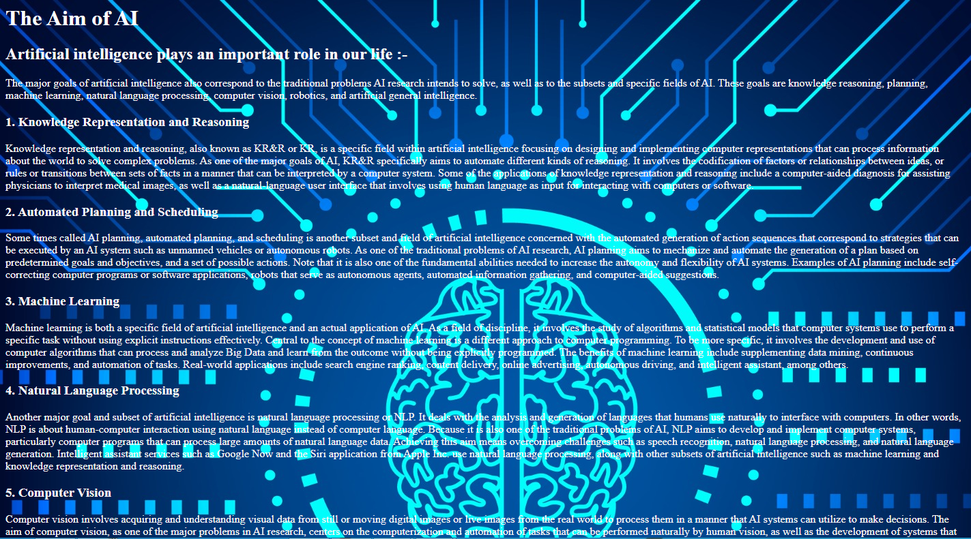

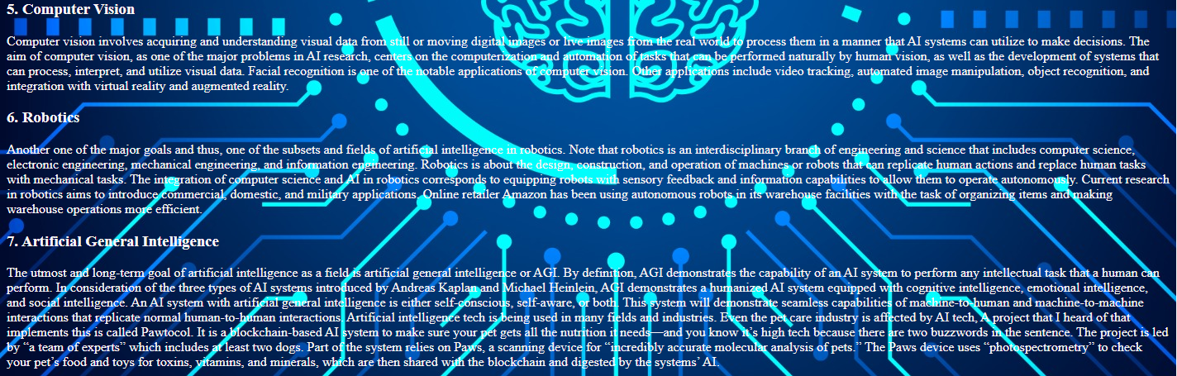

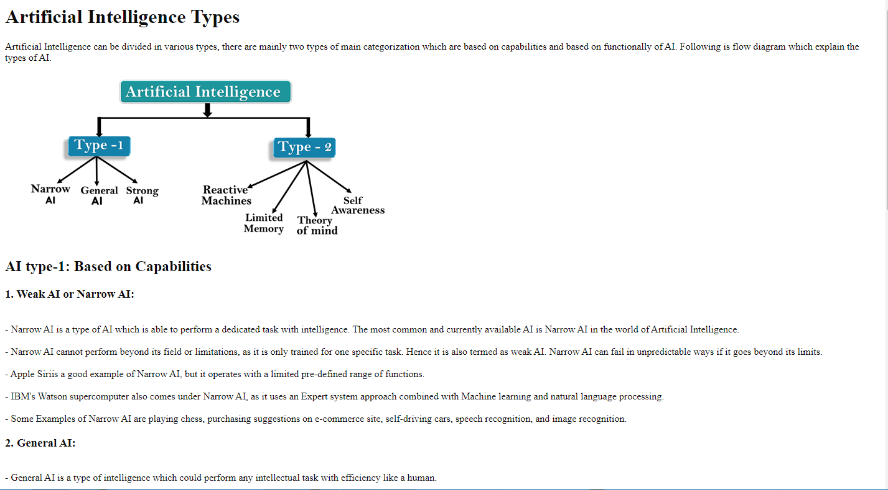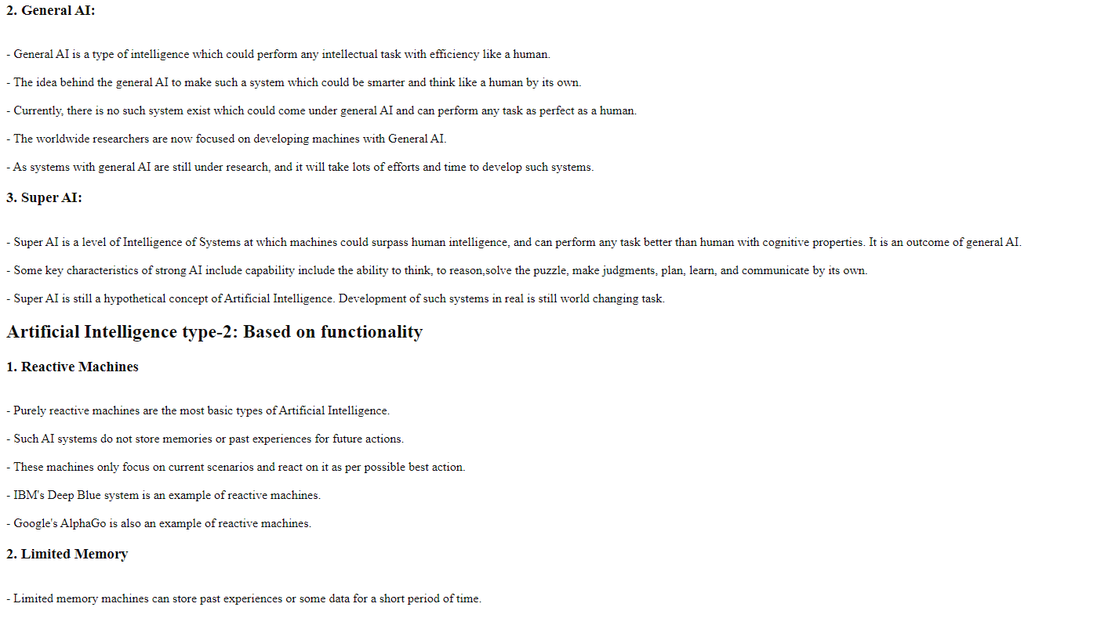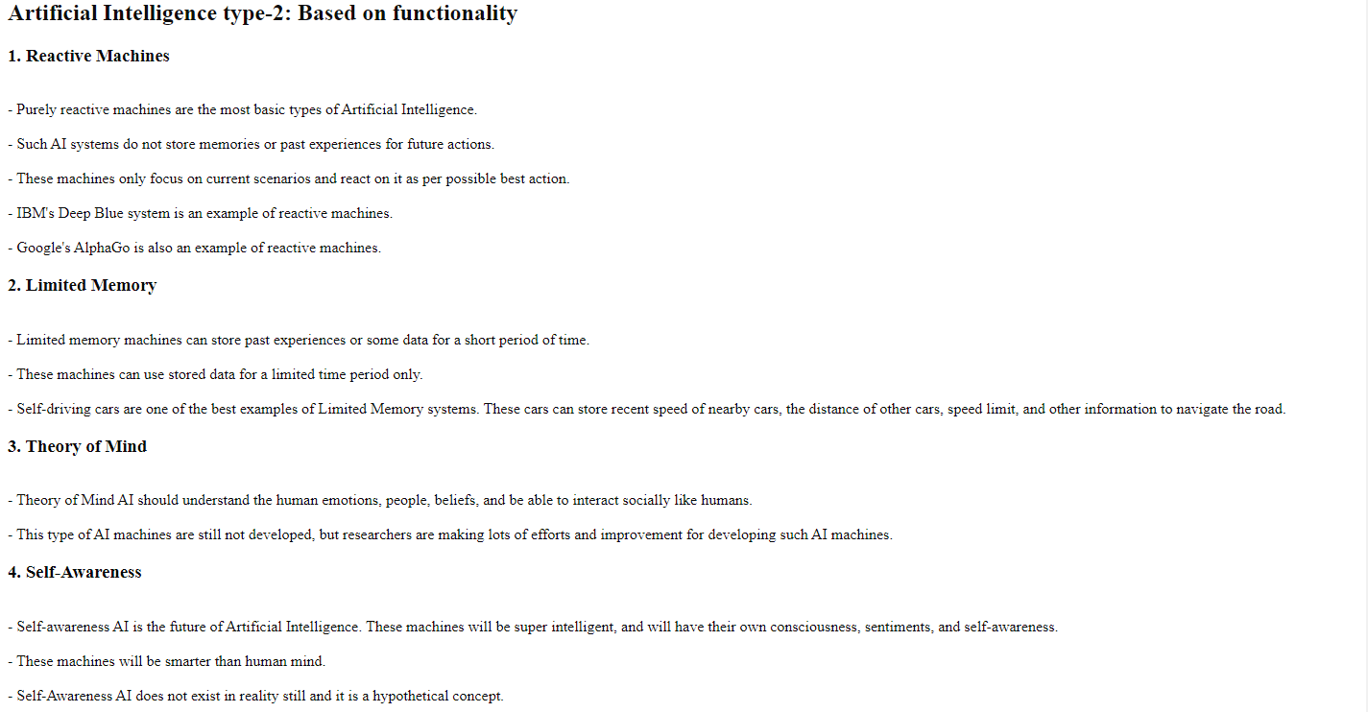

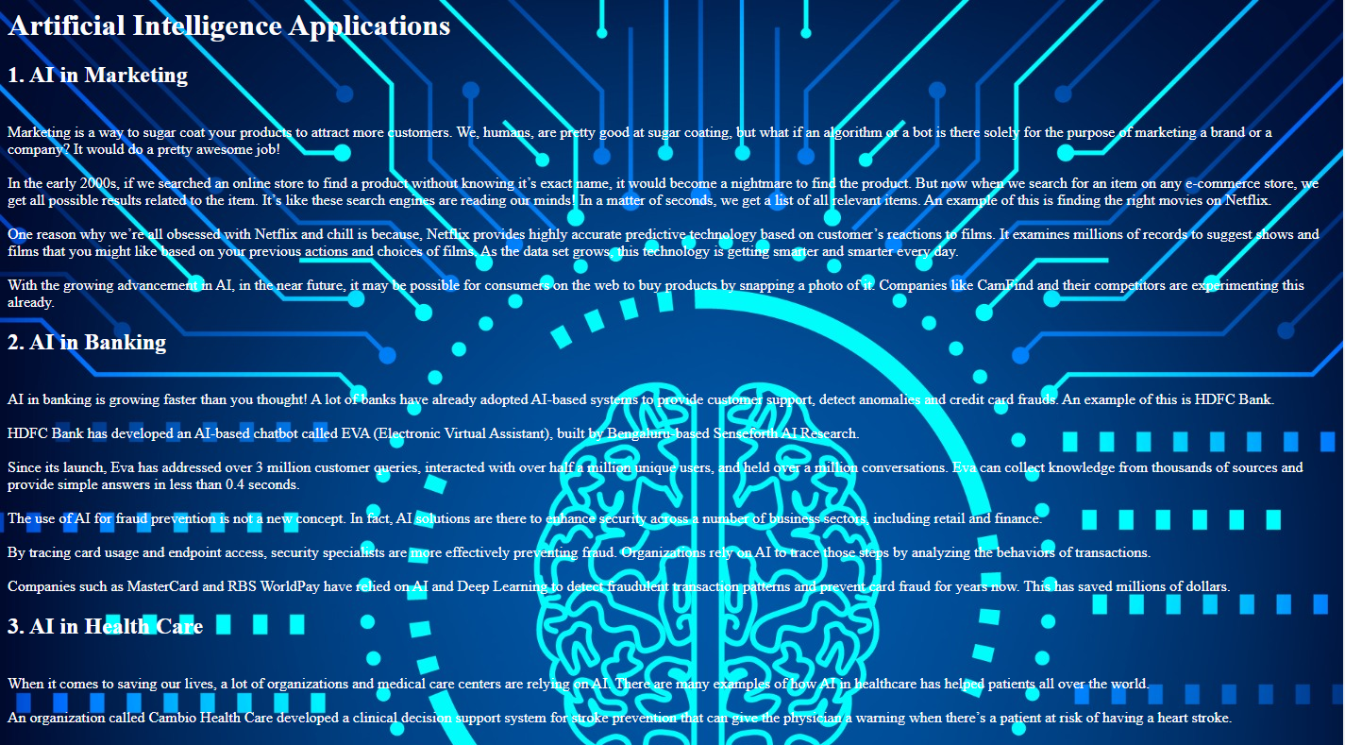

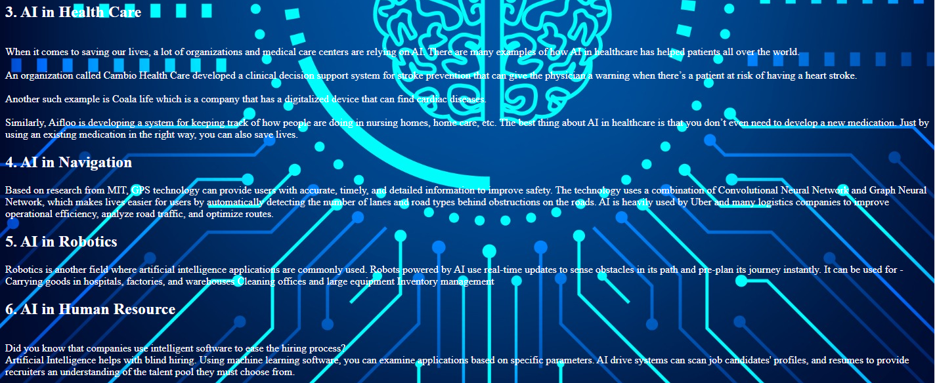

**Screen Shots of Code source**

